EXAM SCORE PREDICTION REPORT
- You load the data into dataframe through the (pd.read_csv) then read through the df.head to understand the structure.
df refers to dataframe
The figure below gives a clear illustrations of how and what has been computed.

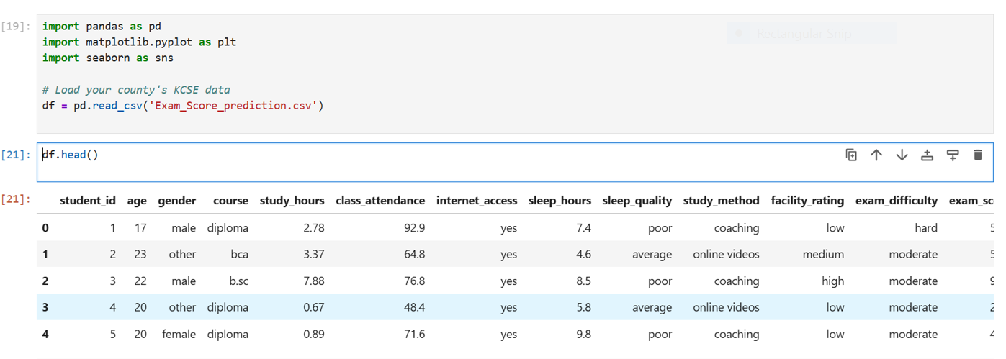

- Students infromation: Here we are getting the mean of three variables which are; class attendance, exam score and study hours of the genders.
You can also view the code used to compute the mean.
A visual view is show in the figure below.

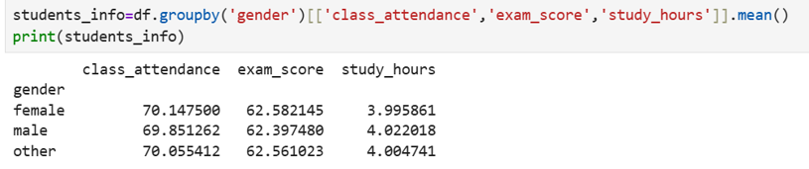

- The figure below shows the code used to plot a graph used to analyze the exam score of the genders.
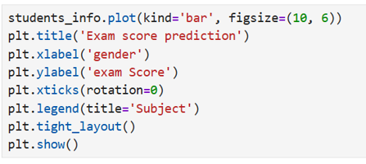

- The graph below show the exam score of the comparison of class attendance, exam score and study hours.
From the analysis we find that female attendant classes more than the other genders, attained a high score in exams and used less study hours.
The other gender was second where it used more less study hours than the male and attained a high score than them but less than the female gender.
The male gender attended classes less than all other genders, attained less exam score but used more time to study than the others.

